Summarizing Data and
Exploring Distributions
Problem Set
The goal of this activity is to summarize numerical data, interpret those summaries, and use theoretical population distributions to estimate the frequency of certain data values.

Research summary

Researchers obtained a sample of 253 college students from a liberal arts college in the northeastern United States. Their students completed questionnaires on sleep, behavior, mood, and college life, in addition to tests to measure cognitive function.
The data and a description of the variables are on our Canvas site, and are titled SleepStudy.csv and SleepStudyDocumentation.docx, respectively.

EXPLORATORY DATA ANALYSIS

Researchers often first perform exploratory data analysis (EDA), an important step in data analysis. EDA is the process of examining the data using descriptive techniques (e.g., sample mean or sample SD) and graphical methods. EDA helps detect mistakes or outliers, checks the validity of assumptions, and gives the researchers ideas for how to analyze the data.

EXAMINING THE DATA

- Load into the data into R or SAS.

- Based on the data dictionary for the dataset, how many categorical variables are there in the dataset? How many quantitative/numerical variables are there?

There is a total of 9 categorical variables. There is a total 21 numerical variables.

- Using your software of choice, examine the variables’ types for each variable in the dataset. Share your code and output.

#input
str(study)

#output
'data.frame': 253 obs. of 27 variables:
$ Gender : int 0 0 0 0 0 1 1 0 0 0 ...
$ ClassYear : int 4 4 4 1 4 4 2 2 1 4 ...
$ LarkOwl : chr "Neither" "Neither" "Owl" "Lark" ...
$ NumEarlyClass : int 0 2 0 5 0 0 2 0 2 2 ...
$ EarlyClass : int 0 1 0 1 0 0 1 0 1 1 ...
$ GPA : num 3.6 3.24 2.97 3.76 3.2 3.5 3.35 3 4 2.9 ...
$ ClassesMissed : int 0 0 12 0 4 0 2 0 0 0 ...
$ CognitionZscore : num -0.26 1.39 0.38 1.39 1.22 -0.04 0.41 -0.59 1.03 0.72 ...
$ PoorSleepQuality: int 4 6 18 9 9 6 2 10 5 2 ...
$ DepressionScore : int 4 1 18 1 7 14 1 2 12 6 ...
$ AnxietyScore : int 3 0 18 4 25 8 0 2 16 11 ...
$ StressScore : int 8 3 9 6 14 28 1 3 20 31 ...
$ DepressionStatus: chr "normal" "normal" "moderate" "normal" ...
$ AnxietyStatus : chr "normal" "normal" "severe" "normal" ...
$ Stress : chr "normal" "normal" "normal" "normal" ...
$ DASScore : int 15 4 45 11 46 50 2 7 48 48 ...
$ Happiness : int 28 25 17 32 15 22 25 29 29 30 ...
$ AlcoholUse : chr "Moderate" "Moderate" "Light" "Light" ...
$ Drinks : int 10 6 3 2 4 0 6 3 3 6 ...
$ WeekdayBed : num 25.8 25.7 27.4 23.5 25.9 ...
$ WeekdayRise : num 8.7 8.2 6.55 7.17 8.67 8.95 8.48 9.07 8.75 8 ...
$ WeekdaySleep : num 7.7 6.8 3 6.77 6.09 9.05 7.73 9.02 8.25 6.6 ...
$ WeekendBed : num 25.8 26 28 27 23.8 ...
$ WeekendRise : num 9.5 10 12.6 8 9.5 ...
$ WeekendSleep : num 5.88 7.25 10.09 7.25 7 ...
$ AverageSleep : num 7.18 6.93 5.02 6.9 6.35 9.04 7.52 9.01 8.54 6.68 ...
$ AllNighter : int 0 0 0 0 0 0 1 0 0 0 ...

- In this problem set, we are going to explore the variables DASscore and AverageSleep. What types of variables are they?

DASscore is an integer and AverageSleep is a numerical. The difference between these two is that the former only contains whole numbers whereas the later contains decimal numbers.

SUMMARIZING THE DATA

- Using your software of choice, calculate summary statistics for the variables: AverageSleep and DASscore. Fill in the values in the table below. Share your code and output.

 | Mean | Median | Q1 | Q3 | IQR | Range | Min | Max | SD
AverageSleep | 7.966 | 8 | 7.43 | 8.5 | 1.16 | 5.67 | 4.95 | 10.62 | 0.96
DASscore | 0 | 16 | 7 | 28 | 21 | 82 | 0 | 82 | 16.54

- Provide an interpretation of the measures of center for the AverageSleep variable, in the context of the problem. (Please answer at most one question on the collaborative key.)
  - Interpret the mean.
The mean of the AverageSleep is 7.966. Meaning that college students on average for this particular college had an average of almost 8 hours of sleep.

  - Interpret the median.
The median of AverageSleep is 8. Meaning that regardless of outliers, students at this college collectively had 8 hours of sleep.

- Provide an interpretation of the measures of spread/variability of the AverageSleep variable, in the context of the problem. (Please answer at most one question on the collaborative key.)
  - Interpret the IQR.
    - The IQR is 1.16 meaning that the spread of the data is accurate since 1.16 is lower.

  - Interpret the range.
The range is between 4.95 – 10.62 hours of sleep. This means that at this college, atleast one student had 4.95 hours of sleep per day, and atleast one student had 10.62 hours of sleep per day.

  - Interpret the SD.
The standard deviation means how far the data is from the mean. In this case, the standard deviation is 0.96. Thus, 0.96 represents the distance from the mean in terms of sleep.
There is little variability in the dataset since the standard deviation is 0.96. Meaning that since the standard deviation is significantly lower than the mean, the data is fairly accurate.

- Provide an interpretation of the remaining statistics in the table for the AverageSleep variable, in the context of the problem. (Please answer at most one question on the collaborative key.)
  - Interpret Q1.
    - Q1 is 7.43 meaning that the first 25% of the data has 7.43 hours of sleep.

  - Interpret Q3.
Q3 is 8.5 meaning that the 75% of the data has 8.5 hours of sleep.

  - Interpret the min.
The minimum is 4.95 meaning that the lowest amount of sleep atleast one college student had in this study was almost five hours.

  - Interpret the max.
The maximum is 10.62 meaning that the highest amount of sleep atleast one college student had in this study was 10.62 hours.

- Based only on the statistics, describe the center and spread for the AverageSleep variable (do not provide or use a graph).

The average amount of sleep is almost 8 hours (7.966) and thus is the center. The beginning of the AverageSleep distribution begins at 4.95 hours and ends at 10.62 hours.

- Based only on the statistics, for AverageSleep (do not provide a graph), which measure of center, the mean or the median, is a better representation of the center of the data? Explain your reasoning.

Considering that the mean and median are fairly close, 7.966 and 8, respectively; the center of the data should be based on either. These values are similar because the AverageSleep distribution does not have much outliers, and thus, resulting in similar values.
- Given your answer for question 9, which measure of spread, the IQR, the Range, or the SD, is a better representation of the variability of the AverageSleep variable? Explain your reasoning.

As stated above, there are an insignificant amount of outliers in this distribution. Therefore, the standard deviation is good representation of the data since the outliers cannot significantly impact this measurement. The standard deviation in this case can tell us how variable our data is; in other words, how far away data points are from the mean.

- Using your software of choice, create a histogram for the DASscore variable. Share your code and output.

hist(study$DASScore,
xlab = "DAS Score",
main = "DAS Score Frequency")
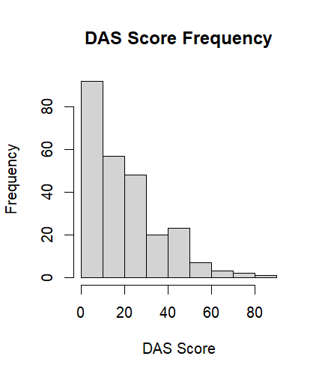

- Using your software of choice, create a boxplot for the DASscore variable. Share your code and output.

boxplot(study$DASScore,
main = "DAS Score Distribution",
xlab = "DAS Score",
ylab = "Frequency")

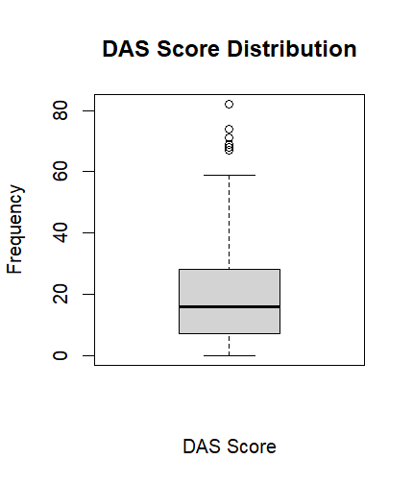

- Using only the graphs in questions 11 and 12, describe the shape, center, and spread for the DASscore variable.

The DAS score variable is right-skewed meaning that most data points are lower values with few values being high. The center of this variable is around ~15, and the spread is between 0-80+ with outliers beginning at values over 60.

- Based on your answer in question 13, for the variable DASscore and your graphs in questions 11 and 12, which measure of center, the mean or the median, would be a better representation of the center of the data for the variable? Explain your reasoning.

The median would be the best representation of the center of the data because the median is robust and resistant to outliers.

- Given your answer for question 14, and based on your graphs in questions 11 and 12, which measure of spread: the IQR, the Range, or the SD, is a better representation of the variability of the DASscore variable? Explain your reasoning.

The IQR is the best representation of the DASscore variable because it is robust and resistant to outliers.

- Which summary measures for measures of center and measures of spread are less influenced by extreme values? Explain your reasoning.

The median and IQR are less influenced by extreme values because these measures are based on middle values / the order of values rather than the values themselves.

Now that we have explored how to describe the data, let us look in more detail at our graphs.
- Using the software of your choice, create a boxplot for the AverageSleep variable. Please share your code and output.

boxplot(study$AverageSleep,
main = "AverageSleep Boxplot",
xlab = "Average sleep")
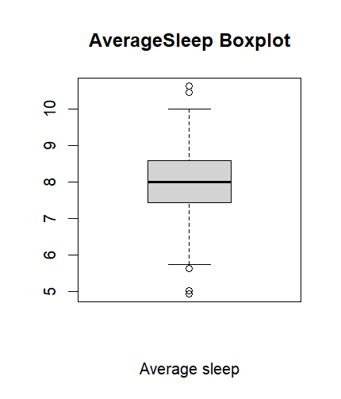
- For the boxplots in questions 12 and 17, what does the vertical line in the middle (for horizontal boxplots) or horizontal line in the middle (for vertical boxplots) of the box represent and what is the value for each variable?
The vertical line represents the difference between Q1 and Q3.
The horizontal line represents Q2. Q1 = 7.43, Q3 = 8.5, minimum = 4.95, maximum = 10.62.

- For the boxplots in questions 12 and 17, what do the lines at the left or right (for horizontal boxplots) or top and bottom (for vertical boxplots) of the box represent and what are their values for each variable? What percent of the data values for the variable AverageSleep of the data values are contained in the box?

- For the boxplots in questions 12 and 17, what do the whiskers represent for each variable?

- For the boxplot in questions 12 and 17, are there outliers that were identified using the 1.5*IQR rule? If so, which variable had potential outliers? Using the graph, approximately how many VALUES were there? (Note: if more than one person had the same value, software will most likely only show one dot. So we are focusing on the number of unique values as opposed to the number who are outliers.)

- Using the 1.5*IQR rule, determine if a student who averages 5 hours of sleep a night is an outlier.

No the student who averages 5 hours of sleep per night is not an outlier. An outlier would be anyone who gets -24.5 hours of sleep, meaning that they stay up for more than a day.

- For the histograms, how many “bins” or “buckets” were created by default for the AverageSleep variable?

There are 13 bins created by default.

- Using your software of choice, modify the bin widths to be small for the AverageSleep variable. Share your code and output. (Share at most two unique graphs in the collaborative key.)
hist(study$AverageSleep,
breaks = 15)
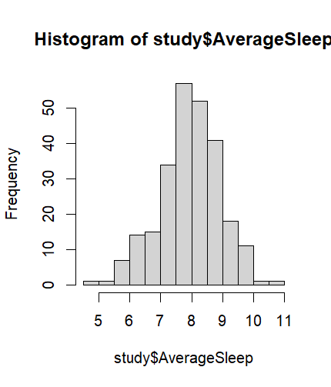

- Using your software of choice, modify the bin widths to be large for the AverageSleep variable. Share your code and output. (Share at most two unique graphs in the collaborative key.)

- What happens to the appearance of the histogram when the number of bins is very small? What happens when the number of bins is very large?

When there are a very large number of bins, the histogram still maintains it’s symmetrical shape but appears more specific. When the number of bins is small, the histogram appears more compact with the y-axis becoming larger.
hist(study$AverageSleep,
breaks = 5)
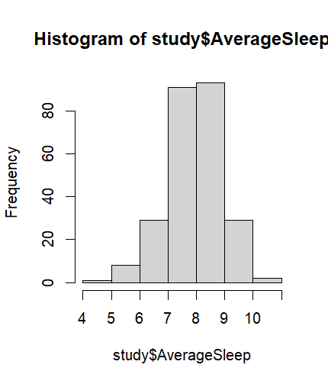

hist(study$AverageSleep,
breaks = 50)

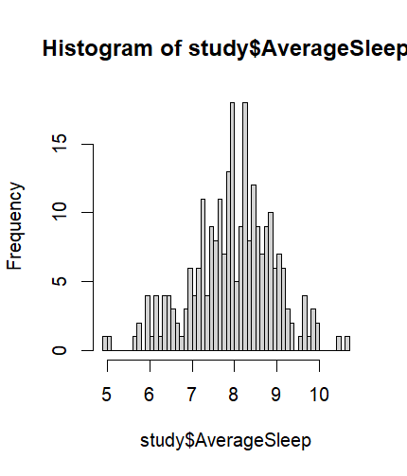

- What number of bins do you think best represents this particular variable? Explain your reasoning.

- Which of the two plots – boxplot or histogram – do you think is the best representation of the variables? Explain your reasoning.

- Which variable, AverageSleep or DASscore, appears to be approximately normally distributed (note: normal distributions are, by definition, symmetric, but symmetric distributions don’t have to be normal)? Explain your reasoning.
The AverageSleep variable seems to be approximately normally distributed bc it is symmetrical, whereas, the DASScore is skewed to the right.

POPULATION DISTRIBUTION FOR AVERAGE SLEEP

Let’s pretend that the distribution average sleep for students at this college has a mean and standard deviation we saw for the variable AverageSleep in our sample, as was summarized in question 4.

- Based on your answer to question 29 and the information above, what would be the (approximate) distribution for average sleep? Write it out in words and in notation form.

For questions 31-34, you will use an online applet for the Normal distribution. To access the applet, follow the directions below:
- Go to http://lock5stat.com/statkey/.
- In the third block from the top, labeled Theoretical Distributions, click on the Normal tab.
- On the right side of the screen, click the Edit Parameters button.
- Enter the values for the mean and the standard deviation of AverageSleep that you denoted in question 4.

We are going to use this Normal Distribution applet to find the probability of selecting a person within a range of possible baseline hemoglobin levels.
- If you click on the button to the left of Left Tail, you will find the probability that a randomly selected person has a value below a number.
- If you click on the button to the left of Two-Tail, you will find the probability that a randomly selected person has a value below a number.
- If you click on the button to the left of Right Tail, you will find the probability that a randomly selected person has a value below a number.
Once you make a choice, an arrow or arrows will appear at the bottom of the graph. If you click on the number below the arrow, you can change the value to a number of your choice.

- Using this Normal Distribution applet, what is the probability a student sleeps an average of less than 6 hours a night? Show your work by drawing the image by hand or take a screenshot of the applet.

- Using the Normal Distribution applet, what is the probability a students averages between 6 and 9 hours of sleep a night? (Choose the two sided option on the applet and adjust the edges to 6 and 9). Show your work by drawing the image by hand or take a screenshot of the applet.

- Using the Normal Distribution applet, what is the probability a student averages more than 9 hours of sleep a night? Show your work by drawing the image by hand or take a screenshot of the applet.

- Using the Normal Distribution applet, what is the probability a student averages between 6.04 and 8.90 hours of sleep a night? Show your work by drawing the image by hand or take a screenshot of the applet.

- Using your software of choice, verify the probability of question 31. Share your code and output.

- Using your software of choice, verify the probability of question 32. Share your code and output.

- Using your software of choice, verify the probability of question 33. Share your code and output.

- Suppose you converted the AverageSleep distribution into a Standard Normal distribution. (Please answer at most one question on the collaborative key.)
  - Find the Z-score for a student who averages 7.5 hours of sleep a night, and interpret what that value means in the context of the problem.

  - Find the Z-score for a student who averaged 9.5 hours of sleep a night, and interpret what this value means in the context of the problem.

Onyper, S. V., Thacher, P. V., Gilbert, J. W., & Gradess, S. G. (2012). Class start times, sleep, and academic performance in college: a path analysis. Chronobiology International, 29(3), 318-335.

